CCP Report
Quiz Game



Group Members:
Saham Abdullah CT-25194
Ayan Khan CT-25181
BCIT FIRST YEAR
SECTION D

Index
- Project Title
- Abstract
- Why is this Problem being solved
- Project Methodology
  - Dataset / Input Data
  - Tools and Technologies
  - Objectives
  - Algorithm
  - Algorithm Explanation
  - Flowchart
  - Flowchart Explanation
- Justification – Why It Is a Complex Computing Problem
- Product Potential
- Program Implementation
- Code
- Conclusion

Project Title:
Quiz Game in C Programming Language
This project presents the design and development of a console-based quiz game created in the C programming language.
It allows the player to answer multiple-choice questions and introduces lifeline features that mimic popular TV quiz formats such as Who Wants to Be a Millionaire.
The player earns points for correct answers and may use lifelines like 50/50 (to eliminate two wrong answers) or Hint (to receive a small clue).
Each lifeline can be used only once during the game, which introduces an element of strategy and state tracking.

Abstract:

This report describes the structure, logic, and implementation of an advanced version of a console quiz game written in C.

The program demonstrates decision-making, function calls, user interaction, and logical control flow.

The game presents a series of general knowledge questions, each with four options.

Before answering, the player may choose to use a lifeline:

50/50 Lifeline: Removes two incorrect options.

Hint Lifeline: Displays a textual clue about the correct answer.

To ensure fairness, each lifeline can be used only once. The game keeps track of which lifelines remain available and displays updates after every question.

This project helps beginners understand not only simple conditional statements but also how to implement function-based modular programming and persistent state across multiple rounds of interaction.

It also emphasizes user experience — giving players choices, feedback, and a sense of progress — all of which are key aspects of interactive program design.

Why is this Problem being solved?

This problem was chosen because it demonstrates how basic programming concepts can be extended to simulate real-world game logic.

A simple question-and-answer system is easy to build, but adding features like lifelines, function calls, and conditional state management makes it a complex yet educational challenge.

Many new programmers learn how to write if and switch statements, but they often struggle to apply those structures in practical scenarios.

This project provides a perfect example of how to:

Combine decision-making with user input.

Use functions to organize code and improve reusability.

Maintain variables (like lifeline availability) across different questions.

It also solves the issue of repetitive, unstructured programming by introducing modularity — a small helper function uses() is created to manage lifeline availability messages.

Thus, the project not only strengthens core programming logic but also introduces early-stage software design thinking.
Project Methodology:
The methodology followed in developing the lifeline-based quiz game included these main steps:
Planning: Deciding on question structure, lifeline behavior, and scoring.
Algorithm Design: Writing step-by-step logic for question flow and lifeline use.
Coding: Implementing the logic using C syntax with structured programming techniques.
Testing: Running multiple test inputs to ensure lifelines, scoring, and input handling worked as expected.
Evaluation: Observing whether the program produced correct output and smooth user interaction
- 4.1 Dataset / Input Data
This quiz game uses a static dataset embedded in the code.
Each question contains four possible answers, stored as simple text printed using printf().
The dataset is intentionally fixed to focus on algorithm and control flow rather than external file management.

However, additional data (like lifeline states and answers) is stored dynamically using variables:

int use_1 – Tracks whether the 50/50 lifeline is still available.

int use_2 – Tracks whether the Hint lifeline is still available.

int scr – Tracks the score.

char c – Holds the user’s character input.

This input data model helps the program simulate real-time state changes, similar to maintaining player statistics in larger games.
4.2 Tools and Technologies
- Language Used: C Programming
- Compiler: GCC or Turbo C
- IDE: Code::Blocks or Visual Studio Code
- Operating System: Windows / Linux / macOS
- Concepts Applied: Functions, Conditionals, State Tracking, Switch-Case, Input Handling
These technologies allow fast compilation and execution of console-based programs with easy debugging and portability across operating systems.

4.3 Objectives
- To create an interactive, question-based quiz game in C.
- To implement function-based modular programming (uses() function).
- To simulate real-world quiz mechanics like lifelines.
- To track user state (lifelines and score) across multiple rounds.
- To encourage creative thinking and application of control flow concepts.

4.4 Algorithm
Step 1: Start program.
Step 2: Initialize variables — scr = 0, use_1 = 1, use_2 = 1.
Step 3: Display first question and four options.
Step 4: Ask if the user wants to use a lifeline.
Step 5: If yes, offer lifeline menu:
• Option 1 → 50/50 (removes two wrong answers if available).
• Option 2 → Hint (gives a clue if available).
Step 6: Update lifeline availability variables (use_1, use_2).
Step 7: Call function uses(use_1, use_2) to display current lifeline status.
Step 8: Ask for the answer and check correctness.
Step 9: If correct → increment scr.
Step 10: Repeat for next question until all are answered.
Step 11: Display final score.
Step 12: End program.
4.5 Algorithm Explanation–
The algorithm begins by initializing both the score counter and the two lifeline counters.
Each round of the game follows a fixed logical pattern:
- Display question and options.
- Ask if a lifeline will be used.
- Depending on the player’s input, activate the chosen lifeline — if available.
- Call the function uses() to update the player about remaining lifelines.
- Prompt for the final answer and check if it’s correct.
- Adjust the score accordingly.
This process is repeated for every question.
The use of functions introduces reusability and modularity. Instead of writing repetitive code for checking lifeline usage after every question, the uses() function handles it once and is called repeatedly.
The algorithm maintains the principle of state management — tracking what resources (lifelines) remain available as the game progresses.

4.6 Flowchart:
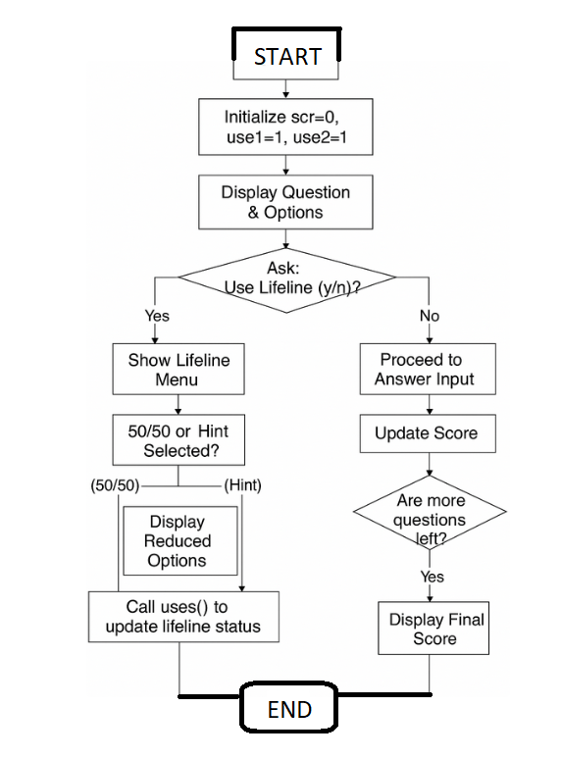

4.7 Flowchart Explanation:

The flowchart illustrates the logical structure of the quiz game.
The main flow begins with initialization of the player’s score and lifeline counters.
At each question node, a branch decision is made — whether or not to use a lifeline.
If a lifeline is selected, an inner process checks its availability.
Depending on the option chosen, the program either gives a clue or eliminates two wrong answers.

After the lifeline phase, control returns to the main flow where the player answers the question.
The program then checks the answer, updates the score, and continues to the next round.
When all questions are complete, or the player has finished using all lifelines, the program terminates with the final score.

5.Justification – Why It Is a Complex Computing Problem
At first glance, the quiz game seems simple, but underneath its surface lies a combination of many fundamental computing concepts. It involves control structures, user interaction, and conditional logic that must work together without errors.

The program has to:

Accept input from the user.

Compare that input with the correct answers.

Keep track of score and remaining lives.

Stop automatically when a losing condition is reached.

Each of these requirements introduces a different aspect of problem-solving. Input handling must account for incorrect entries; conditional logic ensures correct game flow; variable tracking ensures that the player’s progress is maintained accurately.

If we imagine extending this game, complexity increases further: reading questions from files, randomizing question order, timing answers, or even maintaining a player database. These additions would require file handling, dynamic memory allocation, and perhaps even data structures like arrays of structs—all important computing topics.

Therefore, even this small quiz game can be seen as a scaled-down model of real-world software that interacts with users, processes input, and produces outputs according to defined logic.

6.Product Potential
The project can easily evolve into a more sophisticated product.
Possible extensions include:
- Dynamic Question Loading – reading questions from a text or JSON file.
- Graphical Interface – replacing console text with buttons and menus using C GUI frameworks.
- Timed Questions – introducing countdowns for each round.
- Scoring History – saving player performance to external storage.
- Category Modes – science, sports, general knowledge, etc.
With these improvements, the quiz could serve as a classroom learning tool or a mobile trivia app.
Its clear, modular design already provides a strong base for expansion.

7.Program Implementation:
Implementation follows a clean, modular pattern:
a) Variable Initialization

int scr = 0, use_1 = 1, use_2 = 1;
b) Question Display and Input
Questions and options are printed with printf().
The user’s choice is read by scanf(" %c", &c);.
The leading space ensures leftover newline characters don’t interfere with input.
c) Lifeline Handling
Before answering, the user may press y to access lifelines.
The inner menu reads an integer option:
scanf("%d", &option);
d) Function Call
After each lifeline phase, the function
uses(use_1, use_2);
prints which lifelines are still available.
This encapsulation avoids repetitive code, following the modular-programming principle.
e) Answer Checking
Answers are compared with correct letters ('b', 'a', 'c', 'c').
If correct → increment score; otherwise print “Wrong answer!”.
f) Termination and Scoring
After all questions, the final score is printed:
printf("\nYour final score is: %d\n", scr);

8.Code:

Following is the CCP code after planning and execution with output results as well to show a clear and conscience understanding of how it works!

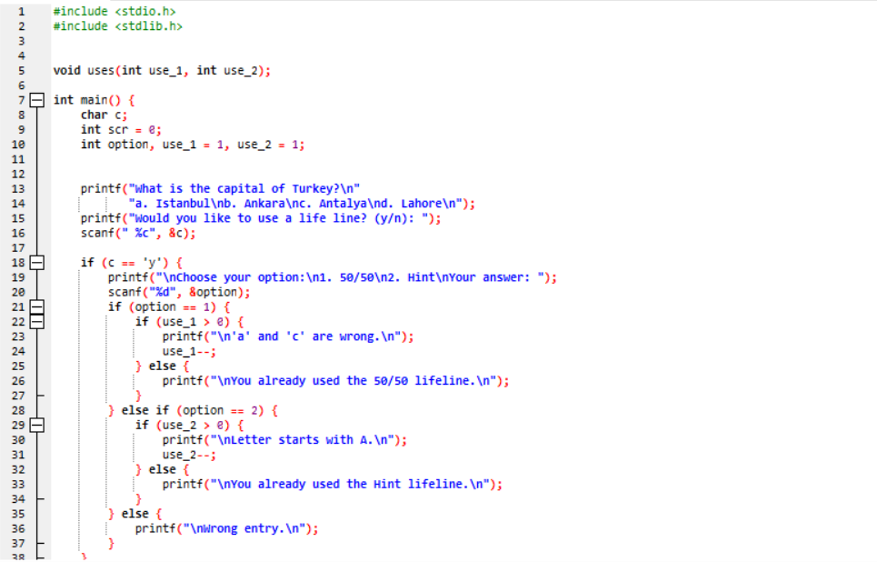



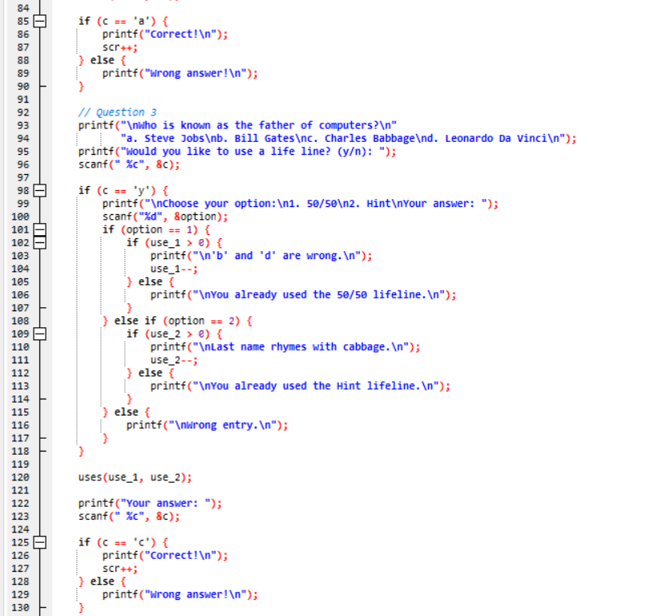
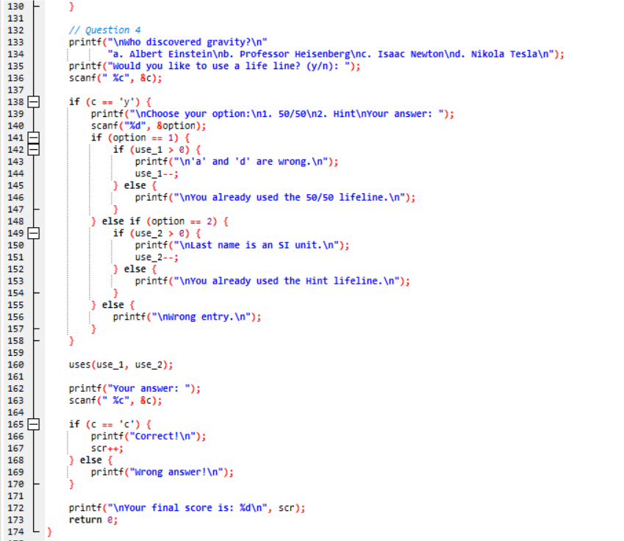

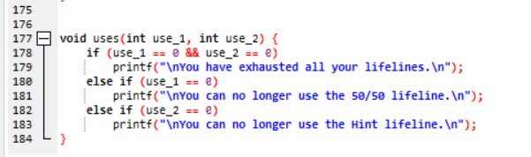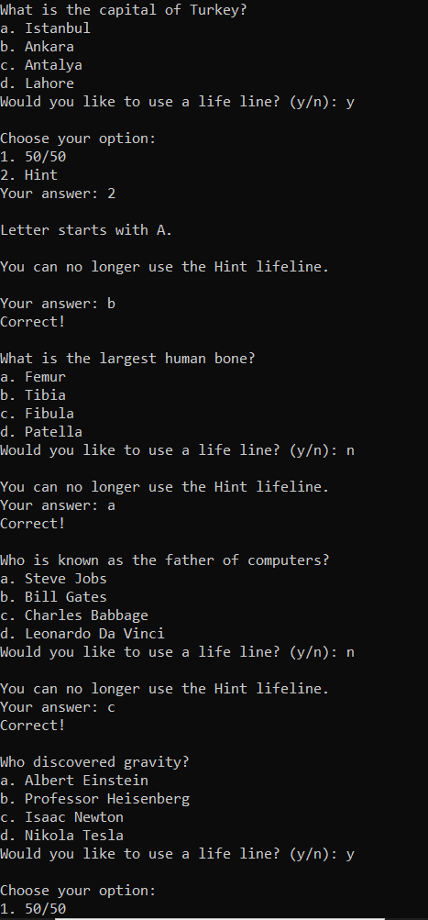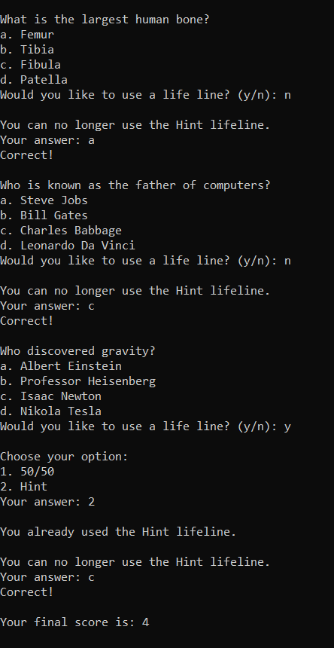

9.Conclusion:
The enhanced Quiz Game in C Programming demonstrates how basic coding principles can evolve into an engaging, interactive system.
It teaches:
- Decision-making through nested if conditions.
- Function modularity and code reuse.
- Variable lifetime and scope control.
- Real-time feedback and user experience design.
The addition of lifelines transforms a simple exercise into a strategic and stateful application, illustrating concepts similar to resource management in larger games.
This project not only fulfills its educational goal but also provides a foundation for future enhancements—such as graphical output, file-based question banks, or multiplayer modes.
By combining logic, creativity, and structure, the project embodies the essence of programming: solving problems through clear, methodical thinking.

